**CERTIFICATE**

This is to certify that this project entitled **“ Army Management System ”** is a bonfire work carried out by **Anusha** bearing **Hall Ticket No: R141065** in **MIT** and submitted to **Rajiv Gandhi University of knowledge Technologies** in partial fulfillment of the requirements for the award of Master **of Computer Applications.**

**Project Guide External Examiner Principal**

#### 

#### ACKNOWLEDGMENT

“Task successful” makes everyone happy. But the happiness will be gold without glitter if we didn’t state the persons who have supported us to make it a success.

Success will be crowned to people who made it a reality but the people whose constant guidance and encouragement made it possible will be crowned first on the eve of success.

This acknowledgement transcends the reality of formality when we would like to express deep gratitude and respect to all those people behind the screen who guided, inspired and helped me for the completion of our project work.

I consider myself lucky enough to get such a good project. This project would add as an asset to my academic profile.

I would like to express my thankfulness to my project guide, Assi.Prof. Shaik Shabana Mam for his constant motivation and valuable help through the project work, and I express my gratitude to **Mr. Bharath**, Director of MIT, Hyderabad, for his constant supervision, guidance and co-operation through out the project.

I also extend my thanks to my Team Members for their co-operation during my course.

Finally I would like to thanks my friends for their co-operation to complete this project.

**Abstract:**

Undertaking Armed force Administration Framework was conceived by the Indian Armed force to empower a quicker choice process by leaders at all echelons, empower better choice because of solid operational data gave continuously. The reports will be vetted by the Army's Integrated Project Management Team  will then issue orders for development of the army management system prototypes within time, as effort is made to hasten creation of the system. The development agencies will choose overseas partners for technical assistance but the tender will only be awarded to the domestic companies under the Make in India category. Once fully developed and proved, army management systems will be critical elements of the Army's network-centric warfare program and will link infantry level troops on the army to the command headquarters. It will also network ground troops with the various Army command headquarters and integrate all elements in a army group, providing real time tactical scenarios.

**CONTENTS**

1. **INTRODUCTION**
   1. INTRODUCTION TO PROJECT
   2. ORGANIZATION PROFILE
   3. PURPOSE OF THE SYSTEM
   4. PROBLEMS IN EXISTING SYSTEM
   5. SOLUTION OF THESE PROBLEMS
2. **SYSTEM ANALYSIS**
   1. INTRODUCTION
   2. ANALYSIS MODEL
   3. STUDY OF THE SYSTEM
   4. SYSTEM REQUIREMENT SPECIFICATIONS
   5. PROPOSED SYSTEM
   6. INPUT AND OUTPUT
   7. PROCESS MODULES USED WITH JUSTIFICATION
3. **FEASIBILITY REPORT**
   1. TECHNICAL FEASIBILITY
   2. OPERATIONAL FEASIBILITY
   3. ECONOMICAL FEASIBILTY
4. **SOFTWARE REQUIREMENT SPECIFICATIONS**
   1. FUNCTIONAL REQUIREMENTS
   2. PERFORMANCE REQUIREMENTS
5. **SELECTED SOFTWARE**
   1. INTRODUCTION TO PHP
   2. HTML
   3. PHP
   4. MYSQL
6. **SYSTEM DESIGN**
   1. INTRODUCTION
   2. NORMALIZATION
   3. E-R DIAGRAM
   4. DATA FLOW DIAGRAMS
   5. DATA DICTIONARY
   6. UML DIAGRAMS
7. **OUTPUT SCREENS**
8. **SYSTEM TESTING AND IMPLEMENTATION**
   1. INTRODUCTION
   2. STRATEGIC APPROACH OF SOFTWARE TESTING
   3. UNIT TESTING
   4. TEST CASES
9. **SYSTEM SECURITY**
   1. INTRODUCTION
   2. SECURITY IN SOFTWARE
10. **CONCLUSION**
11. **FUTURE ENHANCEMENTS**
12. **BIBLOGRAPHY**
    1. **INTRODUCTION TO PROJECT**

The **Indian Army** is the [land-based branch](https://en.wikipedia.org/wiki/Army" \o "Army) and the largest component of the [Indian Armed Forces](https://en.wikipedia.org/wiki/Indian_Armed_Forces" \o "Indian Armed Forces). The [President of India](https://en.wikipedia.org/wiki/President_of_India" \o "President of India) is the [Supreme Commander](https://en.wikipedia.org/wiki/Commander-in-Chief" \o "Commander-in-Chief) of the Indian Army, and it is commanded by the [Chief of Army Staff](https://en.wikipedia.org/wiki/Chief_of_Army_Staff_of_the_Indian_Army" \o "Chief of Army Staff of the Indian Army) , who is a [four-star](https://en.wikipedia.org/wiki/Four-star_rank" \o "Four-star rank) [general](https://en.wikipedia.org/wiki/General_officer" \o "General officer). Two officers have been conferred with the rank of [field marshal](https://en.wikipedia.org/wiki/Field_marshal_(India)" \o "Field marshal (India)), a [five-star rank](https://en.wikipedia.org/wiki/Five-star_rank" \o "Five-star rank), which is a ceremonial position of great honour. The Indian Army originated from the armies of the [East India Company](https://en.wikipedia.org/wiki/East_India_Company" \o "East India Company), which eventually became the [British Indian Army](https://en.wikipedia.org/wiki/British_Indian_Army" \o "British Indian Army), and the armies of the princely states, which finally became the national army after [independence](https://en.wikipedia.org/wiki/Independence_of_India" \o "Independence of India). The units and regiments of the Indian Army have diverse histories and have participated in a number of battles and campaigns across the world, earning a large number of [battle and theatre honours](https://en.wikipedia.org/wiki/Battle_and_theatre_honours_of_the_Indian_Army" \o "Battle and theatre honours of the Indian Army) before and after Independence.

**ORGANIZATION PROFILE**

Software Solutions is an IT solution provider for a dynamic environment where business and technology strategies converge. Their approach focuses on new ways of business combining IT innovation and adoption while also leveraging an organization’s current IT assets. Their work with large global corporations and new products or services and to implement prudent business and technology strategies in today’s environment.

**RANGE OF EXPERTISE INCLUDES:**

* Software Development Services
* Engineering Services
* Systems Integration
* Customer Relationship Management
* Product Development
* Electronic Commerce
* Consulting
* IT Outsourcing

We apply technology with innovation and responsibility to achieve two broad objectives:

* Effectively address the business issues our customers face today.
* Generate new opportunities that will help them stay ahead in the future.

**THIS APPROACH RESTS ON:**

* A strategy where we architect, integrate and manage technology services and solutions - we call it AIM for success.
* A robust offshore development methodology and reduced demand on customer resources.
* A focus on the use of reusable frameworks to provide cost and times benefits.

They combine the best people, processes and technology to achieve excellent results - consistency. We offer customers the advantages of:

**SPEED:**

They understand the importance of timing, of getting there before the competition. A rich portfolio of reusable, modular frameworks helps jump-start projects. Tried and tested methodology ensures that we follow a predictable, low - risk path to achieve results. Our track record is testimony to complex projects delivered within and evens before schedule.

**EXPERTISE:**

Our teams combine cutting edge technology skills with rich domain expertise. What’s equally important - they share a strong customer orientation that means they actually start by listening to the customer. They’re focused on coming up with solutions that serve customer requirements today and anticipate future needs.

**A FULL SERVICE PORTFOLIO:**

They offer customers the advantage of being able to Architect, integrate and manage technology services. This means that they can rely on one, fully accountable source instead of trying to integrate disparate multi vendor solutions.

**SERVICES:**

Xxx is providing its services to companies which are in the field of production, quality control etc with their rich expertise and experience and information technology they are in best position to provide software solutions to distinct business requirements.

**PURPOSE OF THE SYSTEM:**

PHP Programming the Languages mostly commonly used for Website and Web Application Development. PHP is a general purpose, server-side scripting language run a web server that's designed to make dynamic pages and applications. Using PHP as its language has many benefits. PHP is the most popular scripting language for web development. It is free, open source and server-side (the code is executed on the server). MySQL is a Relational Database Management System (RDBMS) that uses Structured Query Language (SQL). It is also free and open source.

**Existing and Proposed System**

**Existing system:**

The Current framework is an electronic framework however which is kept up at individual databases i.e. in exceeds expectations sheets, it's a period defer process. What's more, keeping up every one of the records in Exceed expectations sheets is troublesome. In the event that they need any record they need to look through every one of the records. It doesn't give various client availability and furthermore doesn't have distinctive client benefits. So the framework isn't available for every one of the workers of the association.

**Proposed System:**

The Current framework is an electronic framework however which is kept up at individual databases i.e. in exceeds expectations sheets, it's a period defer process. What's more, keeping up every one of the records in Exceed expectations sheets is troublesome. In the event that they need any record they need to look through every one of the records. It doesn't give various client availability and furthermore doesn't have distinctive client benefits. So the framework isn't available for every one of the agents of the association.

**2.1 INTRODUCTION**

After analyzing the requirements of the task to be performed, the next step is to analyze the problem and understand its context. The first activity in the phase is studying the existing system and other is to understand the requirements and domain of the new system. Both the activities are equally important, but the first activity serves as a basis of giving the functional specifications and then successful design of the proposed system. Understanding the properties and requirements of a new system is more difficult and requires creative thinking and understanding of existing running system is also difficult, improper understanding of present system can lead diversion from solution.

**2.2 ANALYSIS MODEL**

**STUDY OF THE SYSTEM**

In the flexibility of uses the interface has been developed a graphics concepts in mind, associated through a browser interface. The GUI’s at the top level has been categorized as follows

1. Administrative User Interface Design
2. The Operational and Generic User Interface Design

The administrative user interface concentrates on the consistent information that is practically, part of the organizational activities and which needs proper authentication for the data collection. The Interface helps the administration with all the transactional states like data insertion, data deletion, and data updating along with executive data search capabilities.

The operational and generic user interface helps the users upon the system in transactions through the existing data and required services. The operational user interface also helps the ordinary users in managing their own information helps the ordinary users in managing their own information in a customized manner as per the assisted flexibilities.

**Modules:**

A module is a bounded contiguous group of statements having a single name and that can be treated as a unit. In other words, a single block in a pile of blocks.

1. Admin
2. Army chief
3. Agents
4. Registration
5. Reports
6. Authentication

**Admin:**

* Admin login with user id and password.
* Admin can add/view the army chief details.
* Admin view the categories of army weapons details.
* Admin active in the mails.

**Army chief:**

* He login with email id and password.
* He Add/view the agent details.
* He can add/manage the categories of army weapons details.
* He active in the mails.
* He can view/update the own profile details.

**Agents:**

* Agent login with email id and password.
* He view the case details.
* He can send the details of weapons.
* He can active in the mails.
* He can view/update the own profile details.

**Registration:**

The system has a process of registration. Every User need to submit his complete details in the form of registration. Whenever a User registration completed automatically he/she can get a user id and password. By using that user id and password he/she can log into the system.

**Authentication:**

The task is a verification framework that approves client for getting to the framework just when they have input redress secret word. The undertaking includes three levels of client validation. ... Clients would be offered benefit to set passwords as indicated by their desire.

**Reports:**

Different kind of reports is generated by the system.

* + Users Report
  + Weapons Report

**Number of users:**

* Admin
* Army chief
* Agent

**INPUT DESIGN**

Input design is a part of overall system design. The main objective during the input design as given below:

1. To produce cost-effective method of input
2. To achieve the highest possible level of accuracy.
3. To ensure that the input is acceptable and understood by the user.

**Input States:**

The main input stages can be listed as below:

1. Data recording
2. Data transcription
3. Data conversion
4. Data verification
5. Data control
6. Data transmission
7. Data validation
8. Data correction

**Input Types:**

It is necessary to determine the various types of input. Inputs can be categorized as follows:

1. External Inputs which are prime inputs for the system.
2. Internal Inputs, which are user communications with the systems.
3. Operational, which are computer department’s communications to the system?
4. Interactive, which are inputs entered during a dialogue.

**Input Media:**

At this stage choice has to be made about the input media. To conclude about the input media consideration has to be given to:

1. Type of Input
2. Flexibility of Format
3. Speed
4. Accuracy
5. Verification methods
6. Rejection rates
7. Ease of correction
8. Storage and handling requirements
9. Security

10.Easy to use

11.Portability

Keeping in view the above description of the input types and input media, it can be said that most of the inputs are of the form of internal and interactive. As input data is to be directly keyed in by the user, the keyboard can be considered to be the most suitable input device.

**OUTPUT DESIGN:**

Outputs from computer systems are required primarily to communicate the results of processing to users. They are also used to provide a permanent copy of the results for later consultation. The various types of outputs in general are:

1. External Outputs, whose destination is outside the organization,.
2. Internal Outputs whose destination is within organization and they are the
3. User’s main interface with the computer.
4. Operational outputs whose use is purely within the computer department.
5. Interface outputs, which involve the user in communicating directly with User Interface.

**Output Definition:**

The outputs should be defined in terms of the following points:

* Type of the output
* Content of the output
* Format of the output
* Location of the output
* Frequency of the output
* Volume of the output
* Sequence of the output

It is not always desirable to print or display data as it is held on a computer. It should be decided as which form of the output is the most suitable.

For Example

1. Will decimal points need to be inserted
2. Should leading zeros be suppressed.

**Output Media:**

In the next stage it is to be decided that which medium is the most appropriate for the output. The main considerations when deciding about the output media are:

1. The suitability for the device to the particular application.
2. The need for a hard copy.
3. The response time required.
4. The location of the users
5. The software and hardware available.

Keeping in view the above description the project is to have outputs mainly coming under the category of internal outputs. The main outputs desired according to the requirement specification are: The outputs were needed to be generated as a hot copy and as well as queries to be viewed on the screen. Keeping in view these outputs, the format for the output is taken from the outputs, which are currently being obtained after manual processing. The standard printer is to be used as output media for hard copies.

**APPLICATION DEVELOPMENT:**

**N-Tier Applications:**

N-Tier Applications can easily implement the concepts of Distributed Application Design and Architecture. The N-Tier Applications provide strategic benefits to Enterprise Solutions. While 2-tier, client-server can help us create quick and easy solutions and may be used for Rapid Prototyping, they can easily become a maintenance and security night mare

The N-tier Applications provide specific advantages that are vital to the business continuity of the enterprise. Typical features of a real life n-tier may include the following:

1. Security
2. Availability and Scalability
3. Manageability
4. Easy Maintenance
5. Data Abstraction

The above mentioned points are some of the key design goals of a successful n-tier application that intends to provide a good Business Solution.

**Definition:**

Simply stated, an n-tier application helps us distribute the overall functionality into various tiers or layers:

1. Presentation Layer
2. Business Rules Layer
3. Data Access Layer
4. Database/Data Store

Each layer can be developed independently of the other provided that it adheres to the standards and communicates with the other layers as per the specifications.

This is the one of the biggest advantages of the n-tier application. Each layer can potentially treat the other layer as a ‘Block-Box’.

In other words, each layer does not care how other layer processes the data as long as it sends the right data in a correct format.

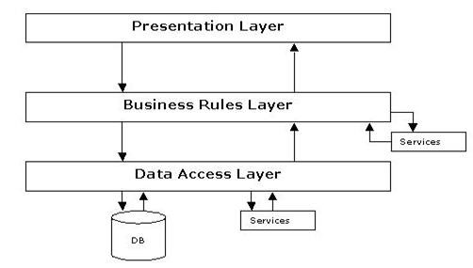

**Fig 1.1-N-Tier Architecture**

1. **The Presentation Layer:**

Also called as the client layer comprises of components that are dedicated to presenting the data to the user. For example: Windows/Web Forms and buttons, edit boxes, Text boxes, labels, grids, etc.

1. **The Business Rules Layer:**

This layer encapsulates the Business rules or the business logic of the encapsulations. To have a separate layer for business logic is of a great advantage. This is because any changes in Business Rules can be easily handled in this layer. As long as the interface between the layers remains the same, any changes to the functionality/processing logic in this layer can be made without impacting the others. A lot of client-server apps failed to implement successfully as changing the business logic was a painful process.

1. **The Data Access Layer:**

This layer comprises of components that help in accessing the Database. If used in the right way, this layer provides a level of abstraction for the database structures. Simply put changes made to the database, tables, etc do not affect the rest of the application because of the Data Access layer. The different application layers send the data requests to this layer and receive the response from this layer.

**4. The Database Layer:**

This layer comprises of the Database Components such as DB Files, Tables, Views, etc. The Actual database could be created using MYSQL, Oracle, etc.   
In an n-tier application, the entire application can be implemented in such a way that it is independent of the actual Database. For instance, you could change the Database Location with minimal changes to Data Access Layer. The rest of the Application should remain unaffected.

**PERFORMANCE REQUIREMENTS:**

Performance is measured in terms of the output provided by the application. Requirement specification plays an important part in the analysis of a system. Only when the requirement specifications are properly given, it is possible to design a system, which will fit into required environment. It rests largely in the part of the users of the existing system to give the requirement specifications because they are the people who finally use the system. This is because the requirements have to be known during the initial stages so that the system can be designed according to those requirements. It is very difficult to change the system once it has been designed and on the other hand designing a system, which does not cater to the requirements of the user, is of no use.

The requirement specification for any system can be broadly stated as given below:

1. The system should be able to interface with the existing system
2. The system should be accurate
3. The system should be better than the existing system

The existing system is completely dependent on the user to perform all the duties.

**2.4 System Requirement Specifications**

**Hardware Requirements:**

Processor : Dual Core

Hard Disk : 40 GB

RAM : 1 GB

**Software Requirements :**

Operating System : Windows 7

User Interface : HTML, CSS, BOOTSTRAP

Client-side Scripting : JavaScript

Programming Language : PHP

Software : XAMPP

Database : MySQL

Web Server : Apache

**2.7 PROCESS MODEL USED WITH JUSTIFICATION**

**ACCESS CONTROL FOR DATA WHICH REQUIRE USER AUTHENTICAION**

The following commands specify access control identifiers and they are typically used to authorize and authenticate the user (command codes are shown in parentheses)

**USER NAME (USER)**

The user identification is that which is required by the server for access to its file system. This command will normally be the first command transmitted by the user after the control connections are made (some servers may require this).

**PASSWORD (PASS)**

This command must be immediately preceded by the user name command, and, for some sites, completes the user's identification for access control. Since password information is quite sensitive, it is desirable in general to "mask" it or suppress type out.

**SOFTWARE REQUIREMENT SPECIFICATION**

The software, Site Explorer is designed for management of web sites from a remote location.

**INTRODUCTION**

**Purpose:** The main purpose for preparing this document is to give a general insight into the analysis and requirements of the existing system or situation and for determining the operating characteristics of the system.

**Scope:** Indian armed force is a standout among the most decent activity in India nobody can even set out to upset you regardless of whether he is a legislator . It is one of the countries most ground-breaking association better believe it is a decent vocation alternative yet for just certain identities . It has an extremely strict control no reservations SC/ST horse crap . Each activity has it's good and bad times there is no 100% perfect calling now it is dependent upon you.

**DEVELOPERS RESPONSIBILITIES OVERVIEW:**

The developer is responsible for:

* Developing the system, which meets the SRS and solving all the requirements of the system?
* Demonstrating the system and installing the system at client's location after the acceptance testing is successful.
* Submitting the required user manual describing the system interfaces to work on it and also the documents of the system.
* Conducting any user training that might be needed for using the system.
* Maintaining the system for a period of one year after installation.

**Functional & Non-Functional Requirements**

**Functional requirements:**

In [software engineering](https://en.wikipedia.org/wiki/Software_engineering" \o "Software engineering) and [systems engineering](https://en.wikipedia.org/wiki/Systems_engineering" \o "Systems engineering), a **functional requirement** defines a function of a [system](https://en.wikipedia.org/wiki/System" \o "System) or its component, where a function is described as a specification of behavior between outputs and inputs. Functional requirements may involve calculations, technical details, data manipulation and processing, and other specific functionality that define what a system is supposed to accomplish. Behavioral requirements describing all the cases where the system uses the functional requirements are captured in [use cases](https://en.wikipedia.org/wiki/Use_case).

**Non-Functional Requirements:**

**Usability**

The system is designed with completely automated process hence there is no or less user intervention.

**Reliability**

The system is more reliable because of the qualities that are inherited from the chosen platform php. The code built by using php is more reliable.

**Performance**

This system is developing in the high level languages and using the advanced front-end and back-end technologies it will give response to the end user on client system with in very less time.

**Supportability**

The system is designed to be the cross platform supportable. The system is supported on a wide range of hardware and any software platform, which is having Apache, built into the system.

**Implementation**

The system is implemented in web environment using core php. The apache is used as the web server and windows xp professional is used as the platform.

**USER INTERFACE DESIGN**

It is essential to consult the system users and discuss their needs while designing the user interface:

**USER INTERFACE SYSTEMS CAN BE BROADLY CLASIFIED AS:**

1. User initiated interface the user is in charge, controlling the progress of the user/computer dialogue. In the computer-initiated interface, the computer selects the next stage in the interaction.
2. Computer initiated interfaces In the computer initiated interfaces the computer guides the progress of the user/computer dialogue. Information is displayed and the user response of the computer takes action or displays further information.

**COMPUTER-INITIATED INTERFACES**

The following computer – initiated interfaces were used:

1. The menu system for the user is presented with a list of alternatives and the user chooses one; of alternatives.
2. Questions – answer type dialog system where the computer asks question and takes action based on the basis of the users reply.

Right from the start the system is going to be menu driven, the opening menu displays the available options. Choosing one option gives another popup menu with more options. In this way every option leads the users to data entry form where the user can key in the data.

**ERROR MESSAGE DESIGN:**

The design of error messages is an important part of the user interface design. As user is bound to commit some errors or other while designing a system the system should be designed to be helpful by providing the user with information regarding the error he/she has committed.

This application must be able to produce output at different modules for different inputs.

**4.2. PERFORMANCE REQUIREMENTS**

Performance is measured in terms of the output provided by the application.

Requirement specification plays an important part in the analysis of a system. Only when the requirement specifications are properly given, it is possible to design a system, which will fit into required environment. It rests largely in the part of the users of the existing system to give the requirement specifications because they are the people who finally use the system. This is because the requirements have to be known during the initial stages so that the system can be designed according to those requirements. It is very difficult to change the system once it has been designed and on the other hand designing a system, which does not cater to the requirements of the user, is of no use.

The requirement specification for any system can be broadly stated as given below:

* The system should be able to interface with the existing system
* The system should be accurate
* The system should be better than the existing system

The existing system is completely dependent on the user to perform all the duties.

**SELECTED SOFTWARE**

**5.1 INTRODUCTION TO PHP**

PHP is an "HTML-embedded scripting language" primarily used for dynamic Web applications. The first part of this definition means that PHP code can be interspersed with HTML, making it simple to generate dynamic pieces of Web pages on the fly. As a scripting language, PHP code requires the presence of the PHP processor. PHP code is normally run in plain-text scripts that will only run on PHP-enabelled computers (conversely programming languages can create stand alone binary executable files, a.k.a. programs). PHP takes most of its syntax from C, Java, and Perl. It is an open source technology and runs on most operating systems and with most Web servers. PHP was written in the C programming language by Rasmus Lerdorf in 1994 for use in monitoring his online resume and related personal information. For this reason, PHP originally stood for "Personal Home Page". Lerdorf combined PHP with his own Form Interpreter, releasing the combination publicly as PHP/FI (generally referred to as PHP 2.0) on June 8, 1995. Two programmers, Zeev Suraski and Andi Gutmans, rebuilt PHP's core, releasing the updated result as PHP/FI 2 in 1997. The acronym was formally changed to PHP: HyperText Preprocessor, at this time. (This is an example of a recursive acronym: where the acronym itself is in its own definition.) In 1998, PHP 3 was released, which was the first widely used version. PHP 4 was released in May 2000, with a new core, known as the Zend Engine 1.0. PHP 4 featured improved speed and reliability over PHP 3. In terms of features, PHP 4 added references, the Boolean type, COM support on Windows, output buffering, many new array functions, expanded object-oriented programming, inclusion of the PCRE library, and more. Maintenance releases of PHP 4 are still available, primarily for security updates. PHP 5 was released in July 2004, with the updated Zend Engine 2.0. Among the many new features in PHP 5 are:

improved object-oriented programming

embedded sqlLite

support for new MySQL features (see the image at right)

exception handling using a try..catch structure

integrated SOAP support (see the image at right)

the Filter library (in PHP 5.1)

better XML tools

iterators

and much, much more. PHP 6 has been in development since October of 2006. The most significant change will be native support for Unicode. Unpopular, deprecated features such as Magic Quotes, register_globals, safe_mode, and the HTTP_*_VARS variables will disappear in PHP 6. Although PHP is still primarily used for server-side generation of Web pages, it can also be used to perform command-line scripting or to create graphical applications with the help of GTK+.

Originally started in 1994 as a replacement for various Perl scripts used to maintain his Personal Web Page (thus the acronym PHP) by the Danish/Greenlandish programmer Rasmus Lerdorf, the project has since grown into an open source community employee. Initial uses of PHP were limited to basic tasks such as counting how many visitors a web site had received, the introduction of PHP/FI (The FI stands for Form Interpreter) added additional functionality including implementation for the C programming language.

In 1995 Lerdorf made the project public in an employee to improve the PHP code base in both reliability and scope. This release would eventually be known as PHP 2. At the time Perl was still the preeminent language for performing the tasks that PHP was seeking to perform and PHP had yet to reach a point where it had the same scope, depth, and consistency offered by Perl.

PHP 3 began in 1997 when a pair of Israeli developers at Technion IIT decided to rewrite the parser. The two would later form Zend Technologies, a company named after blending their two names: Zeev (Suraski) and Andi (Gutmans). The company would eventually produce the Zend Engine, the first public version of which powered PHP 4 upon its release in 2000.

The successor to Zend Engine is the Zend Engine II which was the basis for PHP 5. PHP 5, released in 2004, is perhaps the most radical and some consider long overdue revamp to PHP as it finally brings true Object Oriented Programming (OOP) to developers who have long since grown used to writing object oriented code.

**MySQL**

A database is a structure that comes in two flavors: a flat database and a relational database. A relational database is much more oriented to the human mind and is often preferred over the gabble-de-gook flat database that are just stored on hard drives like a text file. MySQL is a relational database.

MySql is a powerful database. It's very good and free of charge. Many developers in the world selected mysql and php for developing their website.

MySQL is not stopping with version 5.1. Just like they have done since 1995, they are continuing to improve MySQL. MySQL 6.0 is already in the works and it is going to contain referential integrity, additional unicodes, and a new storage engine.

The MySQL database has become the world's most popular open source database because of its consistent fast performance, high reliability and ease of use. It's used in more than 6 million installations ranging from large corporations to specialized embedded applications on every continent in the world. (Yes, even Antarctica!)

Not only MySQL the world's most popular open source database, it's also become the database of choice for a new generation of applications built on the LAMP stack (Linux, Apache, MySQL, PHP / Perl / Python.) MySQL runs on more than 20 platforms including Linux, Windows, OS/X, HP-UX, AIX, Netware, giving you the kind of flexibility that puts you in control. Whether you're new to database technology or an experienced developer or DBA, MySQL offers a comprehensive range of certified software, support, training and consulting to make you successful.

**Introduction JavaScript:**

JavaScript is the most popular scripting language on the internet, and works in all major browsers, such as Internet explorer, Firefox, Chrome, Opera, and Safari.

**What is JavaScript?**

* JavaScript was designed to add interactivity to HTML pages.
* JavaScript is a scripting language.
* A scripting language is a lightweight programming language
* JavaScript is usually embedded directly into HTML pages
* JavaScript is an interpreted language (means that scripts execute without preliminary compilation)
* Everyone can use JavaScript without purchasing a license

Java and JavaScript are two completely different languages in both concept and design! Java (developed by Sun Microsystems) is a powerful and much more complex programming language - in the same category as C and C++.

**What can a JavaScript do?**

JavaScript gives HTML designers a programming tool – HTML authors are normally not programmers, but JavaScript is a scripting language with a very simple syntax! Almost anyone can put small "snippets" of code into their HTML pages JavaScript can put dynamic text into an HTML JavaScript statement like this: document.write("<h1>" + name + "</h1>") can write a variable text into an HTML page. JavaScript can react to events - A JavaScript can be set to execute when something happens, like when a page has finished loading or when a user clicks on an HTML element JavaScript can read and write HTML elements - A JavaScript can read and change the content of an HTML element JavaScript can be used to validate data - A JavaScript can be used to validate form data before it is submitted to a server.

This saves the server from extra processing JavaScript can be used to detect the visitor's browser - A JavaScript can be used to detect the visitor's browser, and - depending on the browser - load another page specifically designed for that browser JavaScript can be used to create cookies - A JavaScript can be used to store and retrieve information on the visitor's computer.

**Introduction to HTML**

HTML, an initialism of Hypertext Markup Language, is the predominant markup language for web pages. It provides a means to describe the structure of text-based information in a document — by denoting certain text as headings, paragraphs, lists, and so on — and to supplement that text with interactive forms, embedded images, and other objects. HTML is written in the form of labels (known as tags), surrounded by angle brackets. HTML can also describe, to some degree, the appearance and semantics of a document, and can include embedded scripting language code which can affect the behavior of web browsers and other HTML processors.

HTML is also often used to refer to content of the MIME type text/html or even more broadly as a generic term for HTML whether in its XML-descended form (such as XHTML 1.0 and later) or its form descended directly from SGML

Hyper Text Markup Language

Hypertext Markup Language (HTML), the languages of the World Wide Web (WWW), allows users to produces Web pages that include text, graphics and pointer to other Web pages (Hyperlinks).

HTML is not a programming language but it is an application of ISO Standard 8879, SGML (Standard Generalized Markup Language), but specialized to hypertext and adapted to the Web. The idea behind Hypertext is that instead of reading text in rigid linear structure, we can easily jump from one point to another point. We can navigate through the information based on our interest and preference. A markup language is simply a series of elements, each delimited with special characters that define how text or other items enclosed within the elements should be displayed. Hyperlinks are underlined or emphasized works that load to other documents or some portions of the same document.

HTML can be used to display any type of document on the host computer, which can be geographically at a different location. It is a versatile language and can be used on any platform or desktop.

HTML provides tags (special codes) to make the document look attractive. HTML tags are not case-sensitive. Using graphics, fonts, different sizes, color, etc., can enhance the presentation of the document. Anything that is not a tag is part of the document itself.

**Attributes**

The attributes of an element are name-value pairs, separated by "=", and written within the start label of an element, after the element's name. The value should be enclosed in single or double quotes, although values consisting of certain characters can be left unquoted in HTML (but not XHTML).Leaving attribute values unquoted is considered unsafe.

Most elements take any of several common attributes: id, class, style and title. Most also take language-related attributes: lang and dir.

The id attribute provides a document-wide unique identifier for an element. This can be used by stylesheets to provide presentational properties, by browsers to focus attention on the specific element or by scripts to alter the contents or presentation of an element. The class attribute provides a way of classifying similar elements for presentation purposes. For example, an HTML document (or a set of documents) may use the designation class="notation" to indicate that all elements with this class value are all subordinate to the main text of the document (or documents). Such notation classes of elements might be gathered together and presented as footnotes on a page, rather than appearing in the place where they appear in the source HTML.

An author may use the style non-attributal codes presentational properties to a particular element. It is considered better practice to use an element’s son- id page and select the element with a stylesheet, though sometimes this can be too cumbersome for a simple ad hoc application of styled properties. The title is used to attach subtextual explanation to an element. In most browsers this title attribute is displayed as what is often referred to as a tooltip. The generic inline span element can be used to demonstrate these various non-attributes.

The preceding displays as HTML (pointing the cursor at the abbreviation should display the title text in most browsers).

**SYSTEM DESIGN**

**6.1. INTRODUCTION**

Software design sits at the technical kernel of the software engineering process and is applied regardless of the development paradigm and area of application. Design is the first step in the development phase for any engineered product or system. The designer’s goal is to produce a model or representation of an entity that will later be built. Beginning, once system requirement have been specified and analyzed, system design is the first of the three technical activities -design, code and test that is required to build and verify software.

The importance can be stated with a single word “Quality”. Design is the place where quality is fostered in software development. Design provides us with representations of software that can assess for quality. Design is the only way that we can accurately translate a customer’s view into a finished software product or system. Software design serves as a foundation for all the software engineering steps that follow. Without a strong design we risk building an unstable system – one that will be difficult to test, one whose quality cannot be assessed until the last stage.

During design, progressive refinement of data structure, program structure, and procedural details are developed reviewed and documented. System design can be viewed from either technical or project management perspective. From the technical point of view, design is comprised of four activities – architectural design, data structure design, interface design and procedural design.

**6.2 NORMALIZATION**

It is a process of converting a relation to a standard form. The process is used to handle the problems that can arise due to data redundancy i.e. repetition of data in the database, maintain data integrity as well as handling problems that can arise due to insertion, updating, deletion anomalies.

Decomposing is the process of splitting relations into multiple relations to eliminate anomalies and maintain anomalies and maintain data integrity. To do this we use normal forms or rules for structuring relation.

**Insertion anomaly**: Inability to add data to the database due to absence of other data.

**Deletion anomaly**: Unintended loss of data due to deletion of other data.

**Update anomaly**: Data inconsistency resulting from data redundancy and partial update

**Normal Forms**: These are the rules for structuring relations that eliminate anomalies.

**6.3 E-R Diagrams**

* + The relation upon the system is structure through a conceptual ER-Diagram, which not only specifics the existential entities but also the standard relations through which the system exists and the cardinalities that are necessary for the system state to continue.
  + The entity Relationship Diagram (ERD) depicts the relationship between the data objects. The ERD is the notation that is used to conduct the date modeling activity the attributes of each data object noted is the ERD can be described resign a data object descriptions.
  + The set of primary components that are identified by the ERD are
  + Data object
  + Relationships
  + Attributes
  + Various types of indicators.

The primary purpose of the ERD is to represent data objects and their relationships.

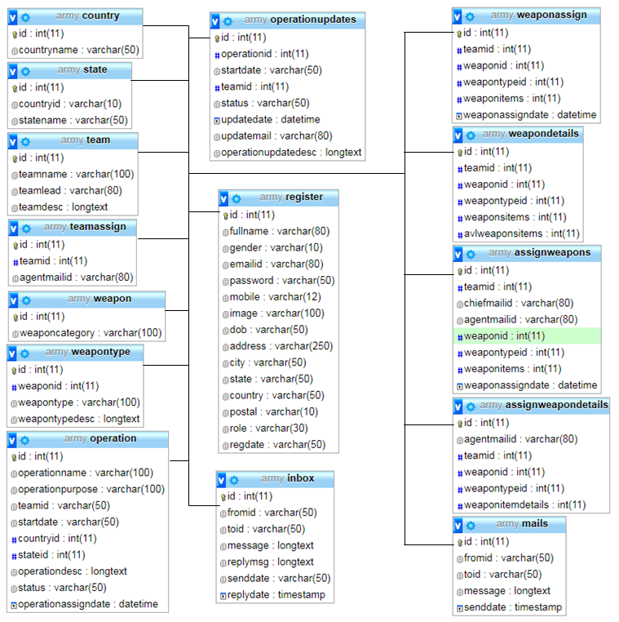

**DFD Diagram:**

**DATA FLOW DIAGRAMS**

A data flow diagram is graphical tool used to describe and analyze movement of data through a system. These are the central tool and the basis from which the other components are developed. The transformation of data from input to output, through processed, may be described logically and independently of physical components associated with the system. These are known as the logical data flow diagrams. The physical data flow diagrams show the actual implements and movement of data between people, departments and workstations. A full description of a system actually consists of a set of data flow diagrams. Using two familiar notations Yourdon, Gane and Sarson notation develops the data flow diagrams. Each component in a DFD is labeled with a descriptive name. Process is further identified with a number that will be used for identification purpose. The development of DFD’S is done in several levels. Each process in lower level diagrams can be broken down into a more detailed DFD in the next level. The lop-level diagram is often called context diagram. It consists a single process bit, which plays vital role in studying the current system. The process in the context level diagram is exploded into other process at the first level DFD.

The idea behind the explosion of a process into more process is that understanding at one level of detail is exploded into greater detail at the next level. This is done until further explosion is necessary and an adequate amount of detail is described for analyst to understand the process.

Larry Constantine first developed the DFD as a way of expressing system requirements in a graphical from, this lead to the modular design.

A DFD is also known as a “bubble Chart” has the purpose of clarifying system requirements and identifying major transformations that will become programs in system design. So it is the starting point of the design to the lowest level of detail. A DFD consists of a series of bubbles joined by data flows in the system.

**DFD SYMBOLS:**

In the DFD, there are four symbols

1. A square defines a source(originator) or destination of system data
2. An arrow identifies data flow. It is the pipeline through which the information flows
3. A circle or a bubble represents a process that transforms incoming data flow into outgoing data flows.
4. An open rectangle is a data store, data at rest or a temporary repository of data

Process that transforms data flow.

Source or Destination of data

Data flow

Data Store

**DFD Diagram:**

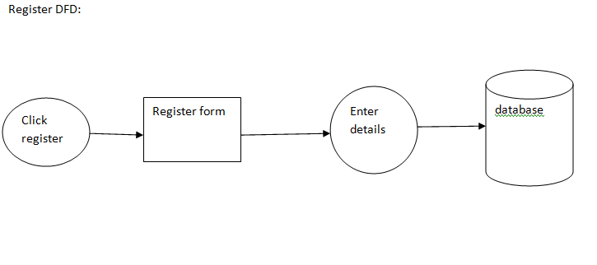

**Login DFD:**



**DFD(Data Flow Diagrams):**

Context Level Data Flow Diagram

country & states

officers & agent

Database

Admin

Data input stageData output stage

Teams

Data input stage

Chief officer

UI screens

Data output stage

Operations

Weapons

Agent

Data input stage

Reports

Data output stage

Mails

Profile

System properties

**Authentication Data Flow Diagram****Admin DFD:**

view agnets

add/view chief officers

add/view country/states

add/view /manage teams

add/view operations

UI content to operation

Login

Admin

add/view weapons

add/view weapon types

General information

assign/view weapons

mails

Logout

**Chief officer DFD:**

add/view/manage agents

view teams

view/operation

view team members

UI content to operation

Login

Chief officer

view/assign weapons

mails

General information

change profile

Logout

**Agent DFD:**

view team

view/manage operation

view weapon

mails

Agent

UI content to operation

Login

change profile

General information

Logout

**Use case diagrams**

**Admin Use case diagram:**



**Chief officer Use case diagram:**



**Agent Use case diagram:**



**Activity Diagrams**

**Admin Activity diagram:**



**Chief officer Activity diagram:**



**Agent Activity diagram:**



**State chart diagrams**

**Admin State chart diagram:**



**Chief officer state chart diagram:**



**Agent State chart diagram:**



**Component diagram:**



**Class Diagram:**



**SCREENS**

**Army Management System –Homepage**

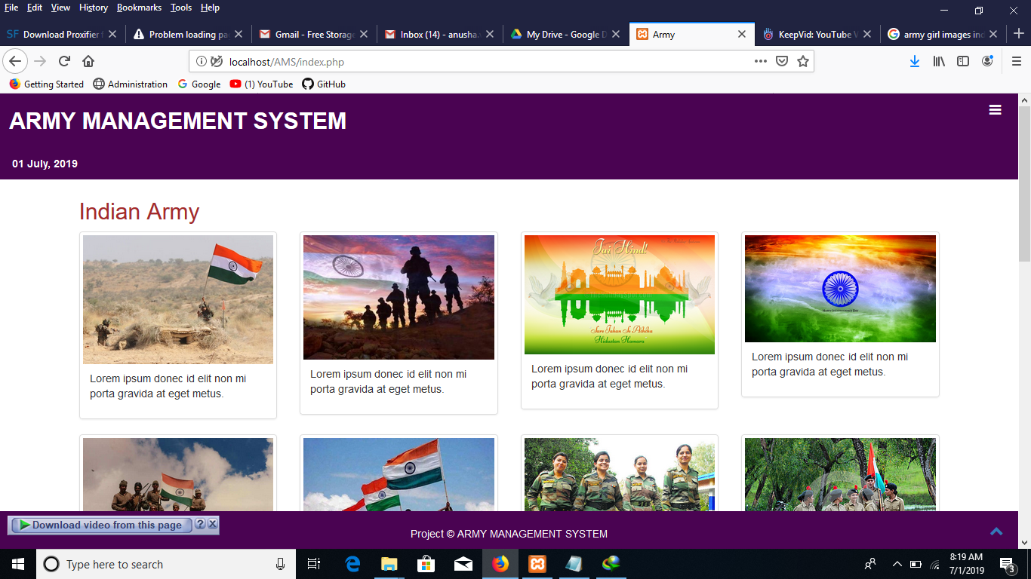

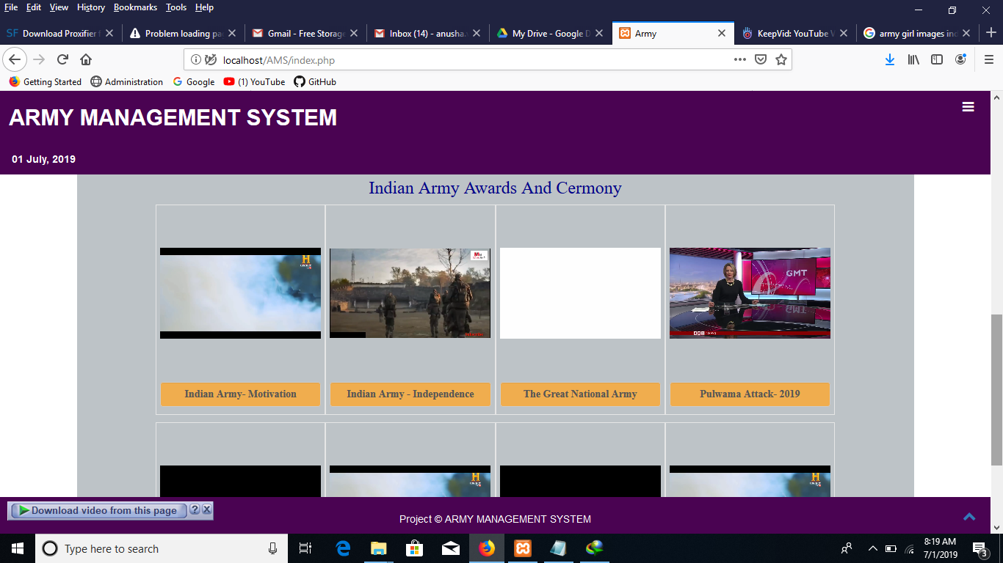

**About:**

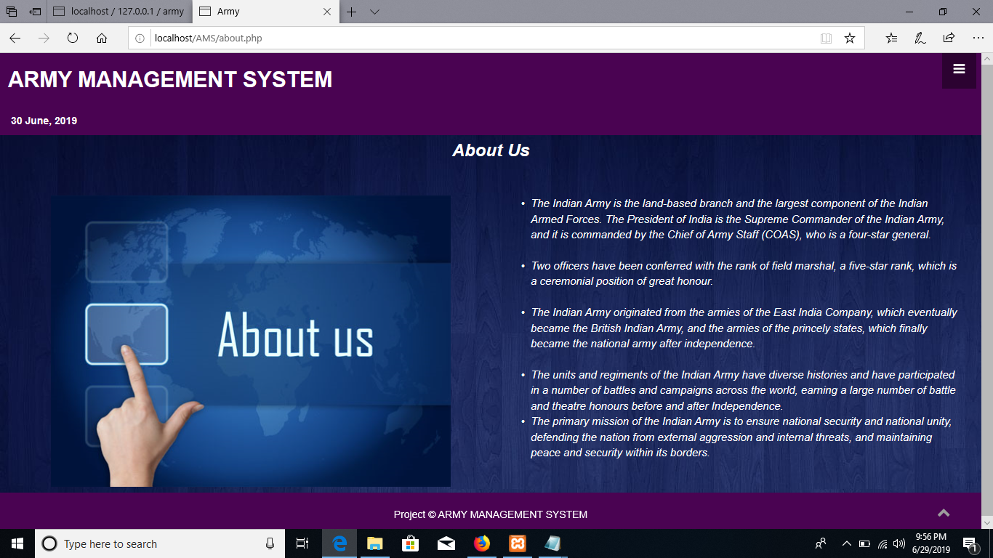

**Service:**

**Contact Us:**

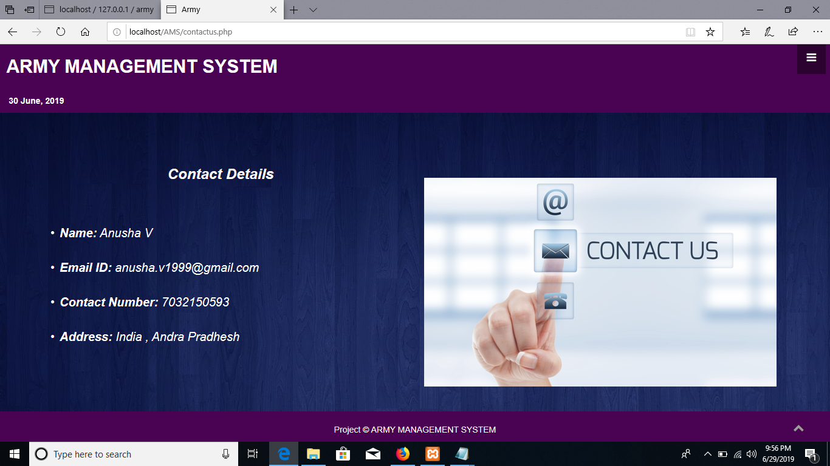

**Login:**

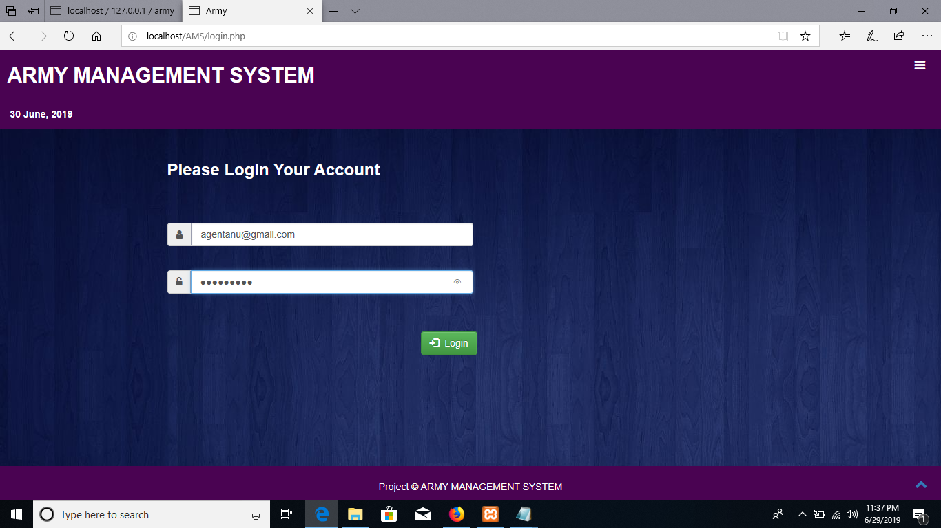

**Admin homepage:**

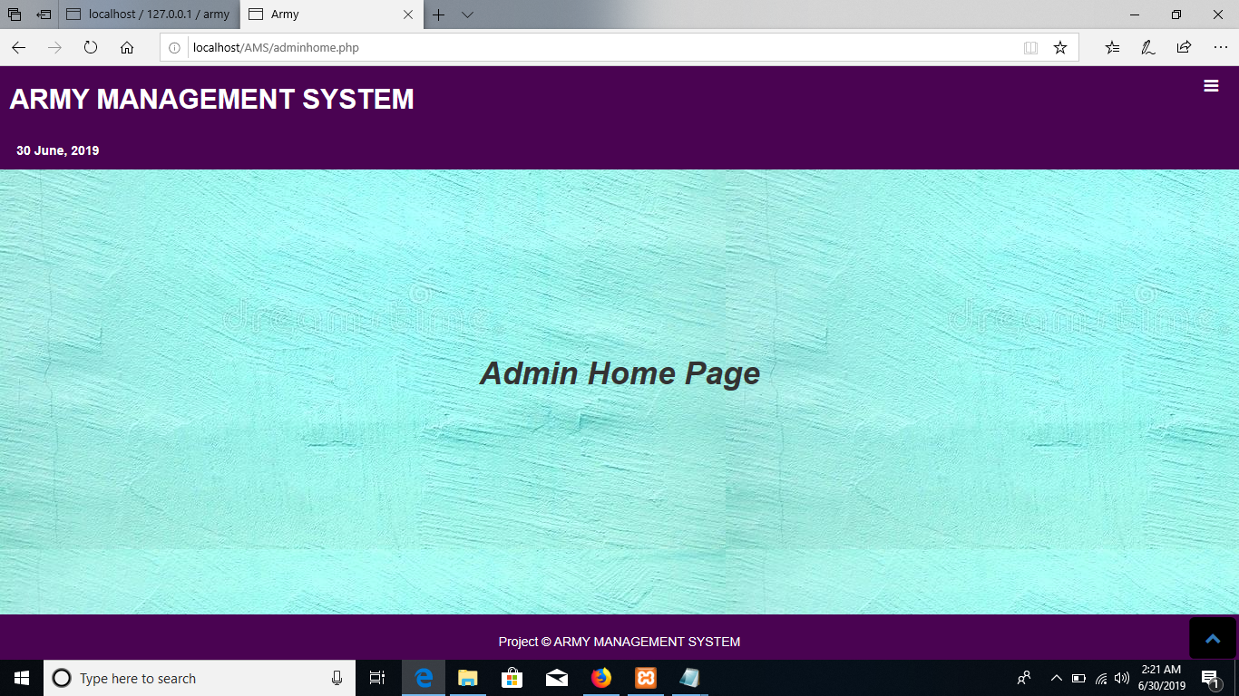

**Chief officer registration &View chief officers:**

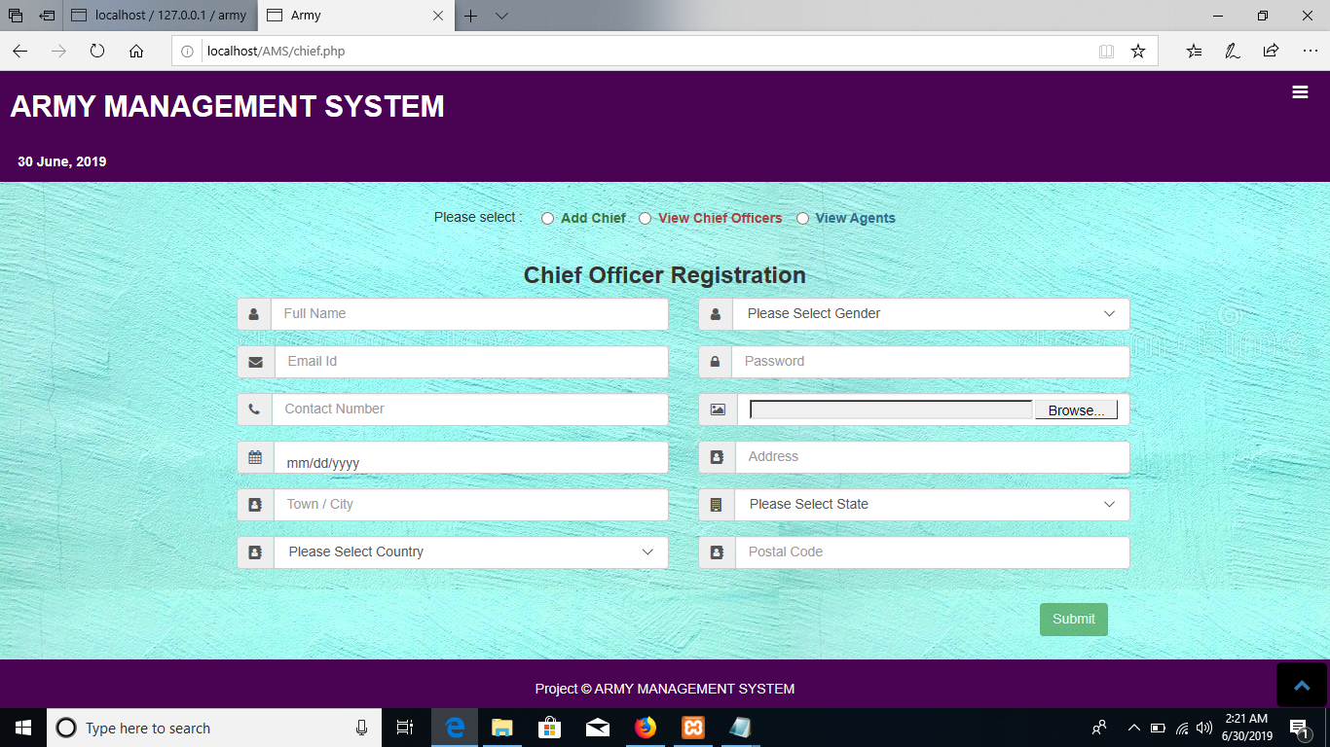

**Add country &View country**

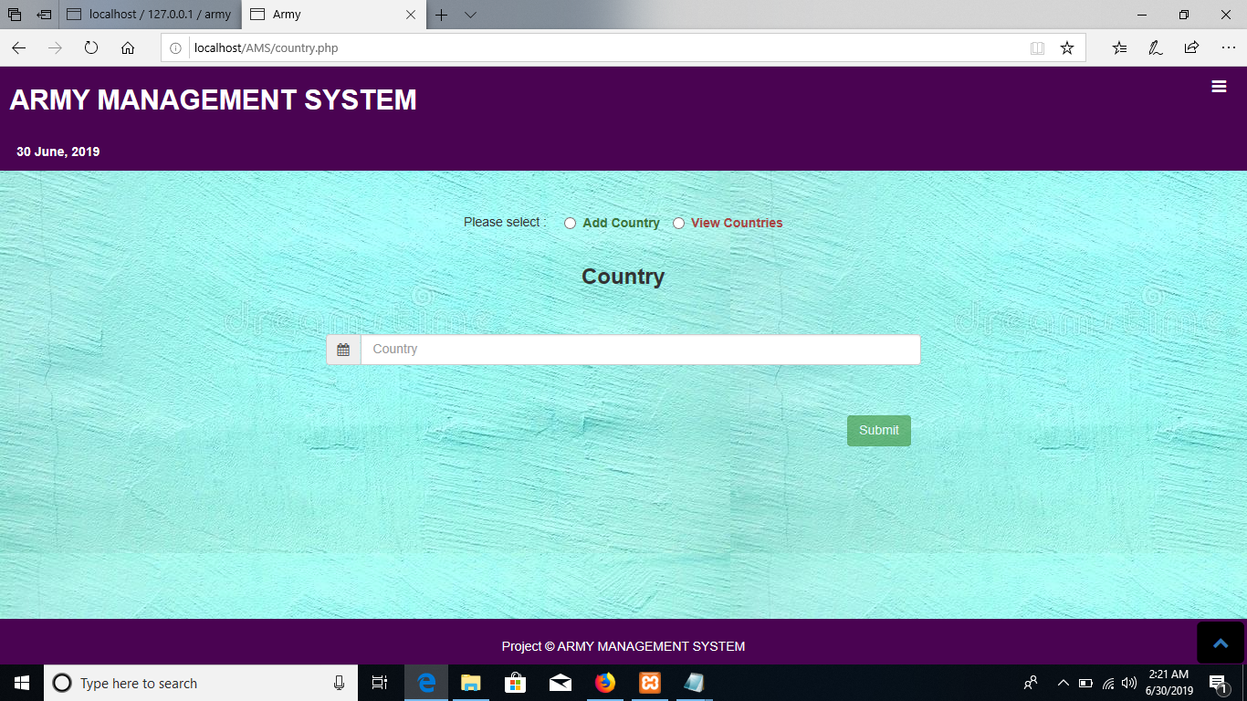

**Add state & View states:**

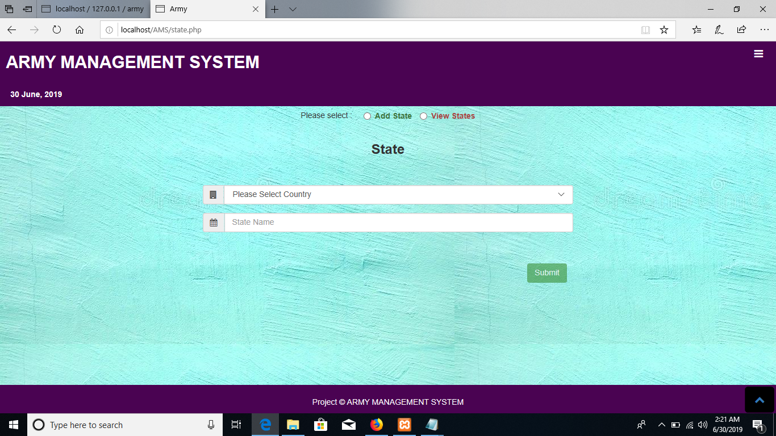

**Add Teams & View Teams**

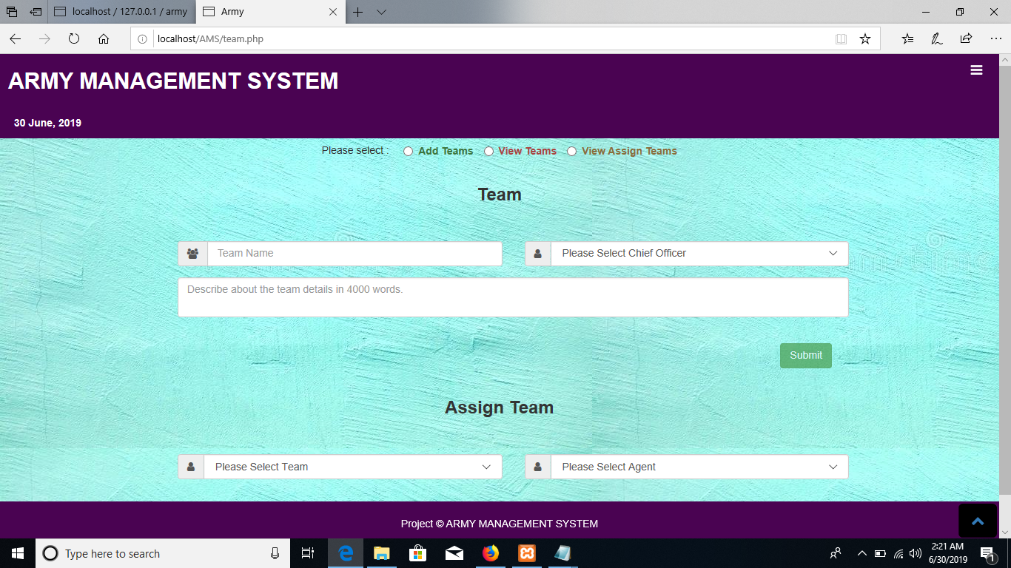

**Add operation & View operations:**

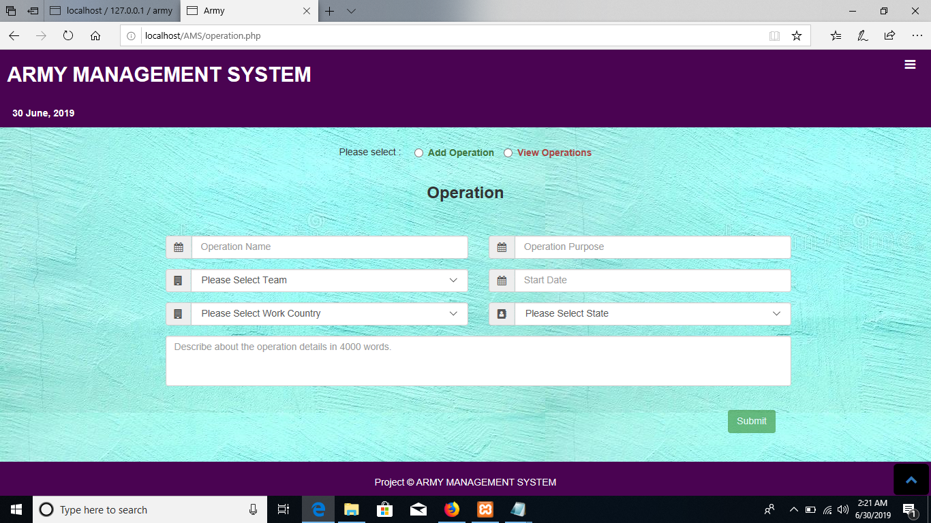

**Update the operation:**

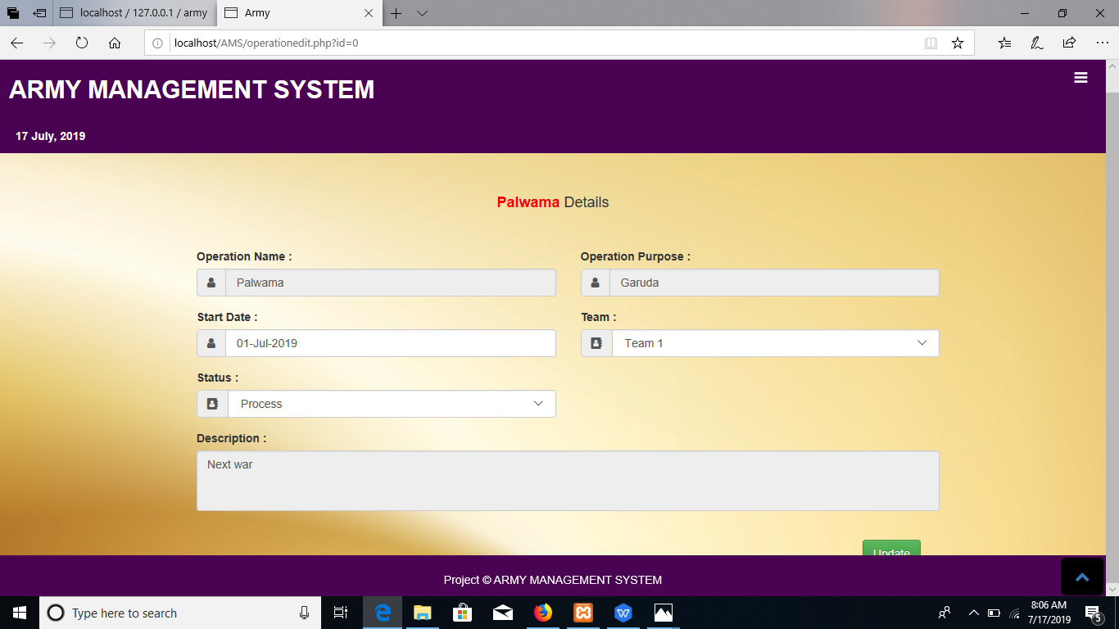

**View the all update reports:**

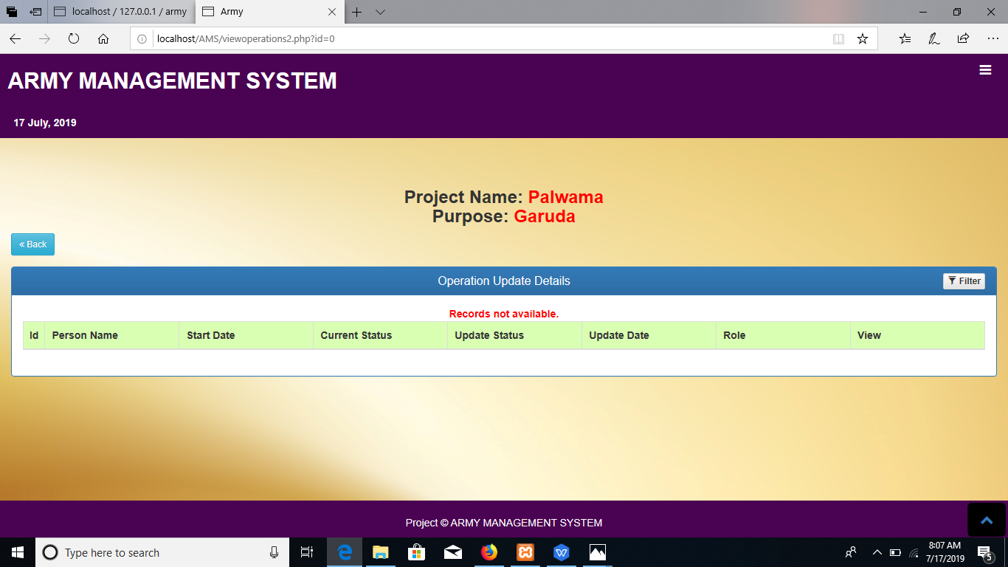

**Add weapons and weapons types & View weapons**

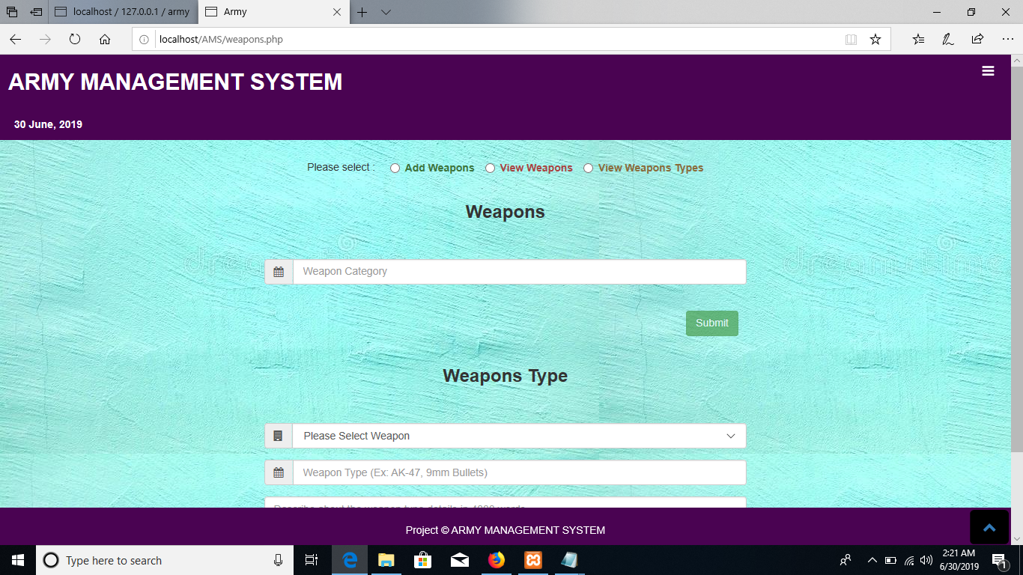

**Chief officer homepage:**

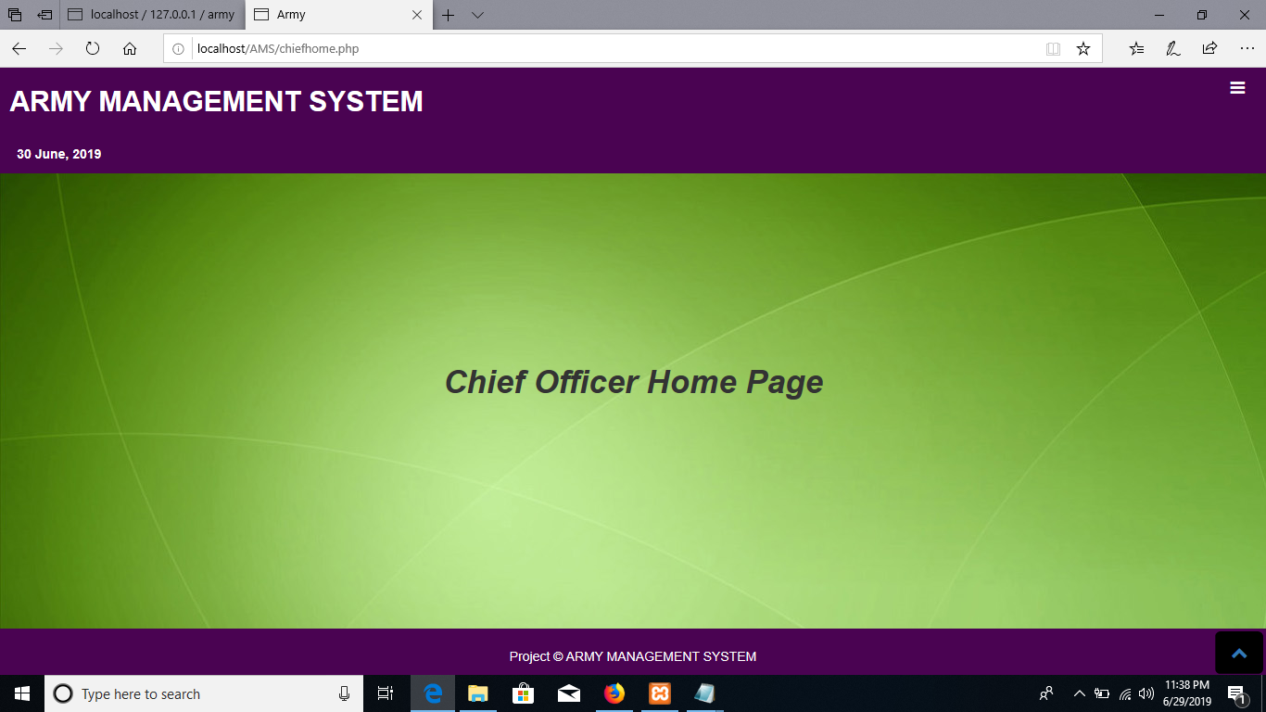

**Agent registration :**

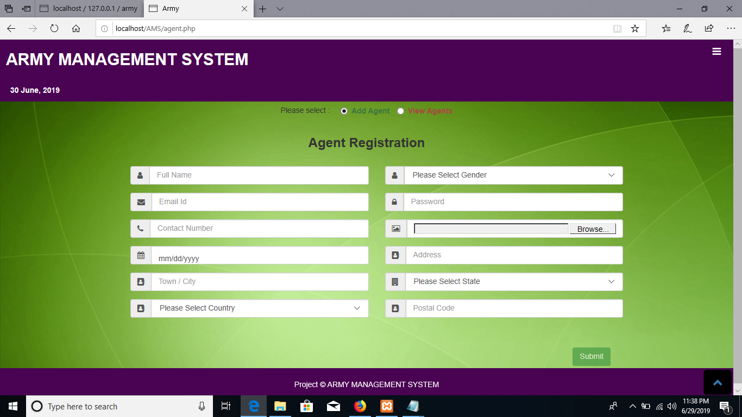

**View agents:**

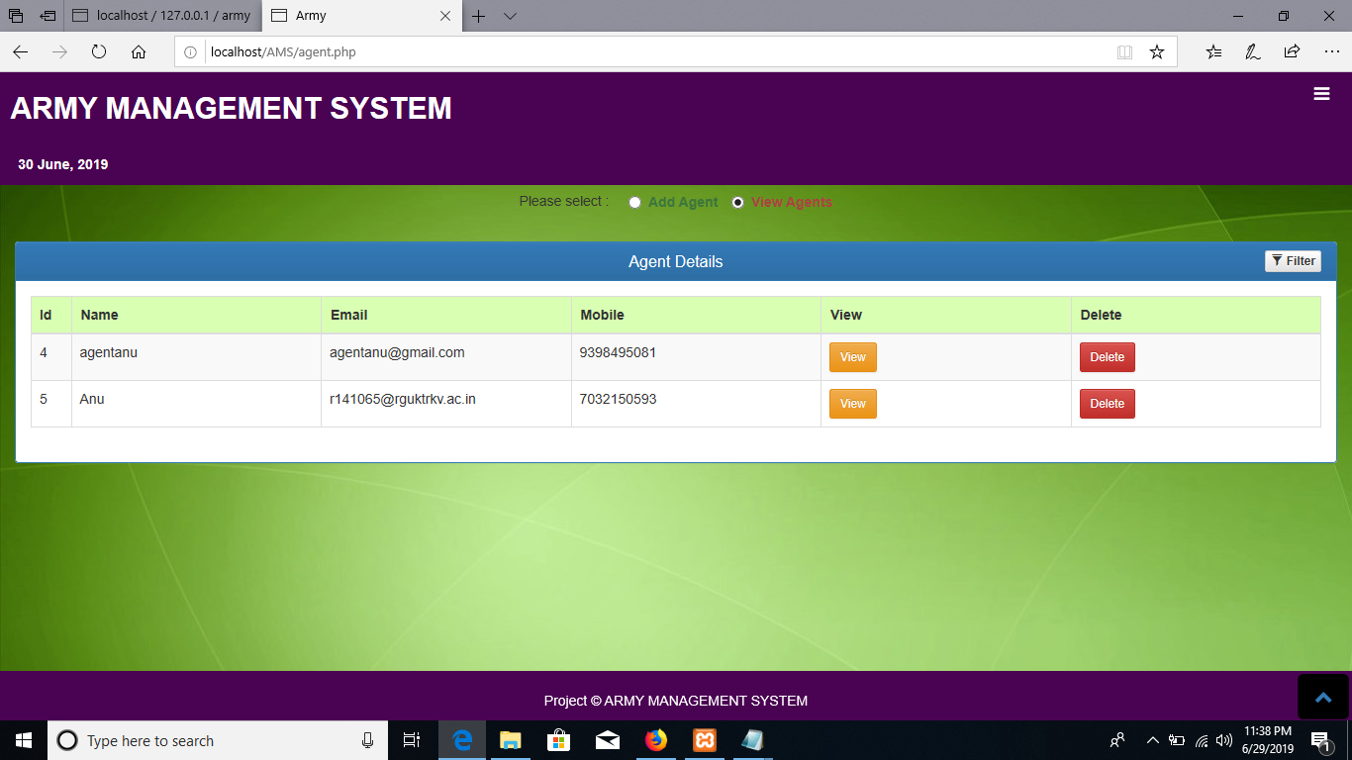

**View teams:**

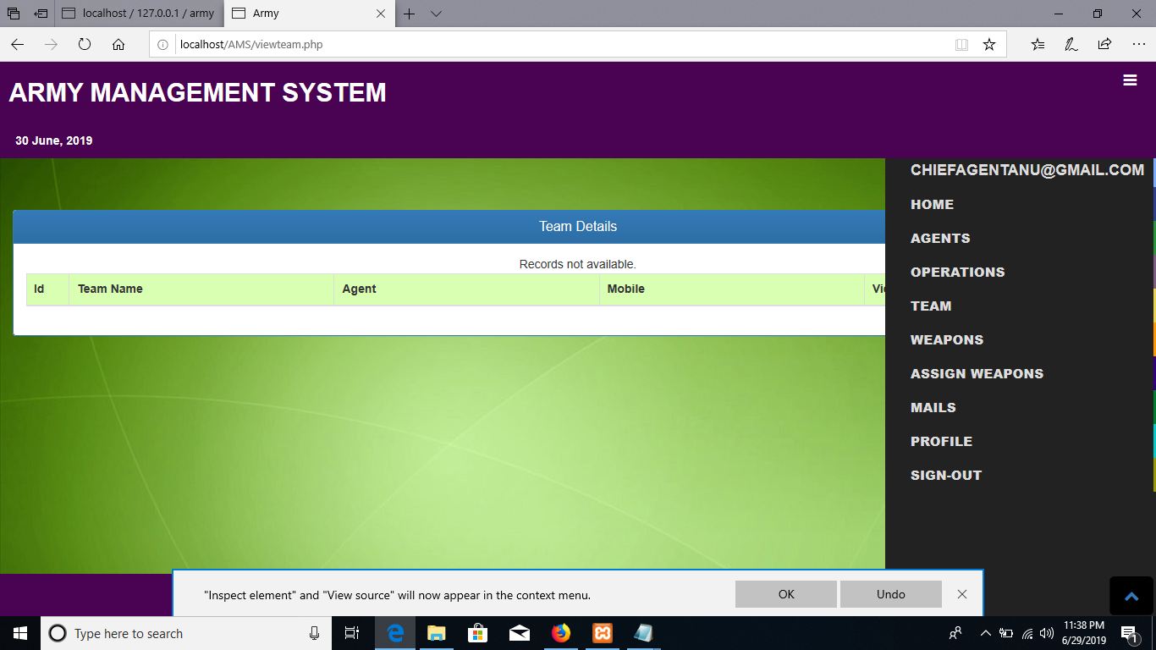**View operations:**

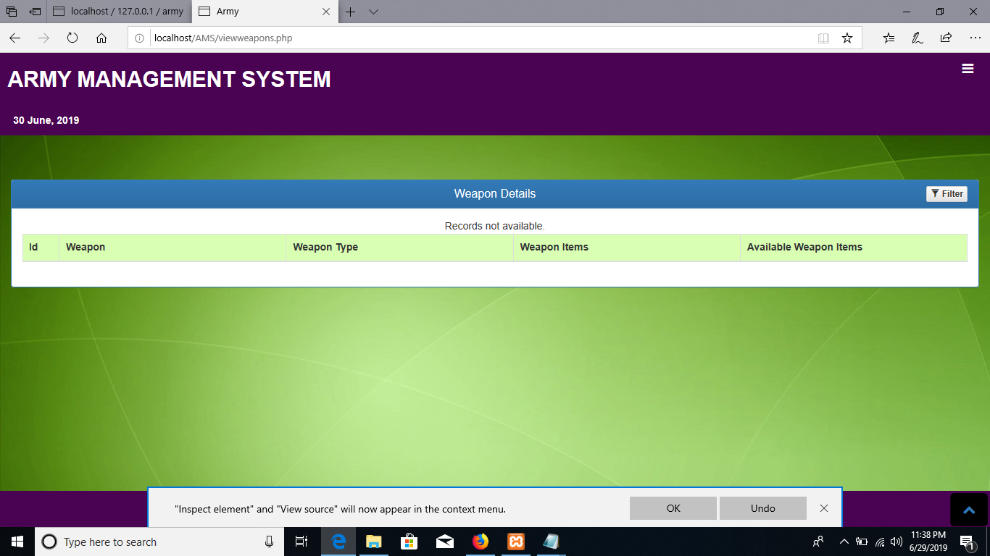

**Add weapons and View Weapons:**

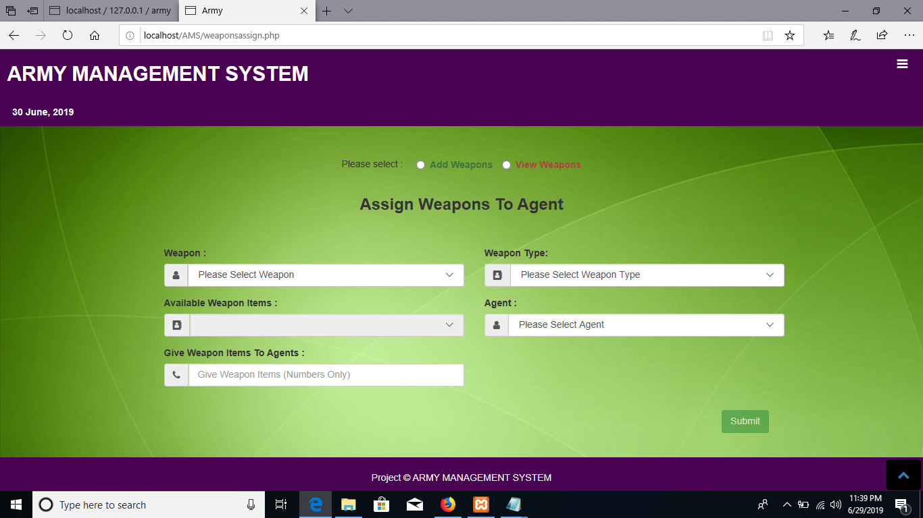

**Compose and Sent Mails:**

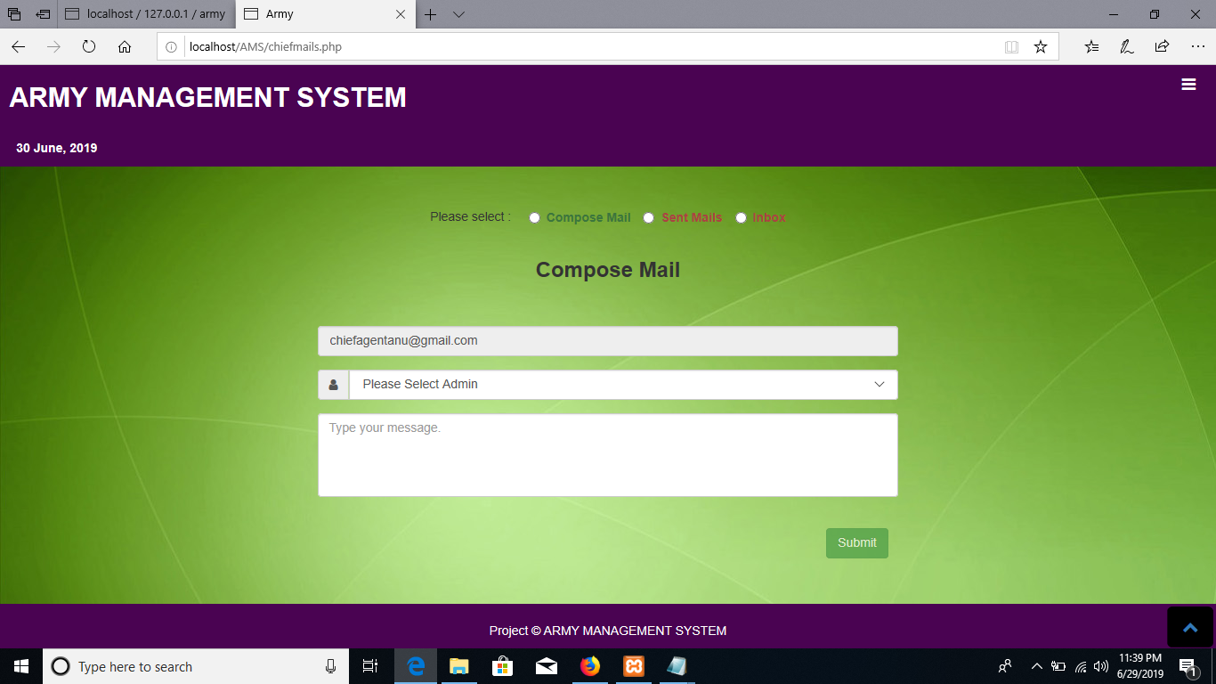

**Chief Profile:**

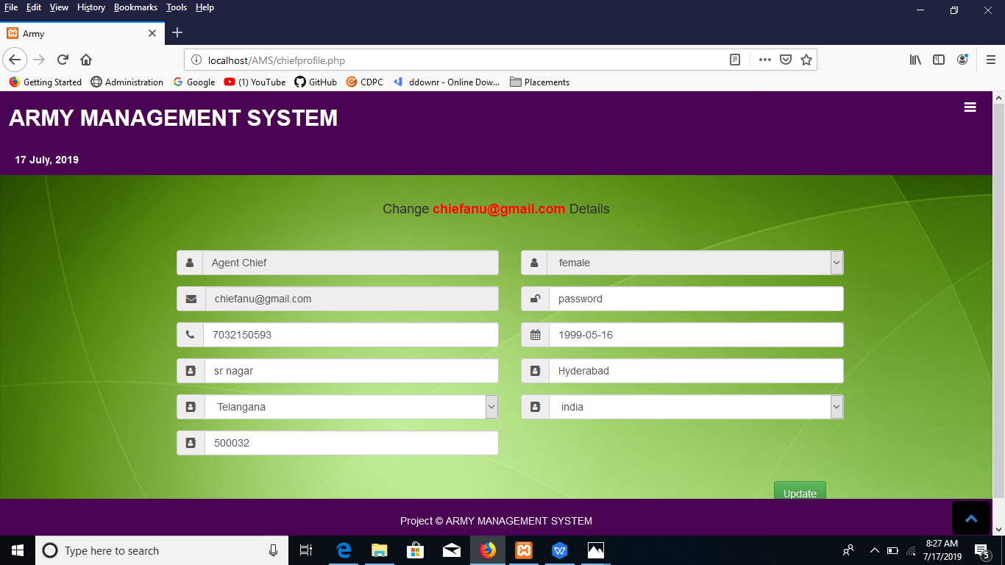

**Agent homepage:**

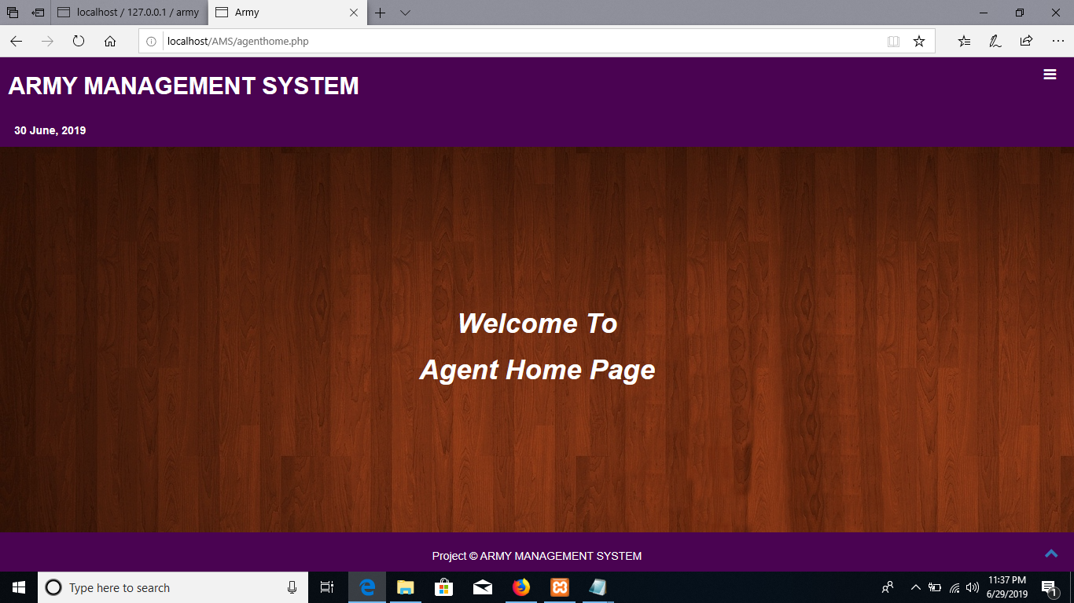

**View Team:**

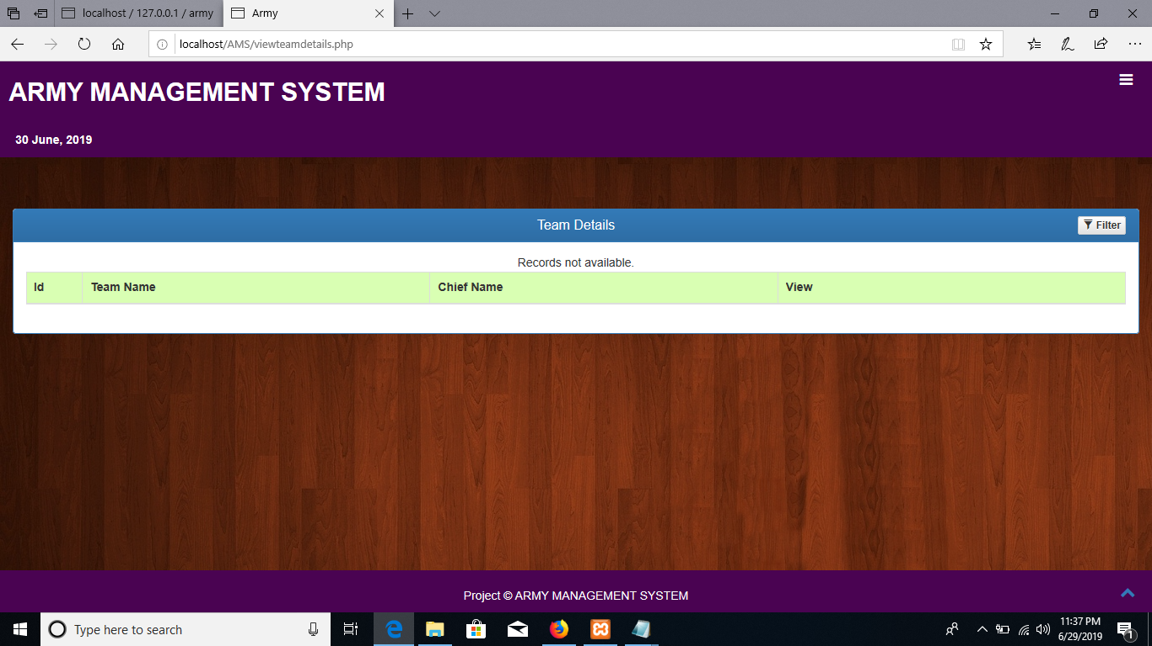

**View Operations:**

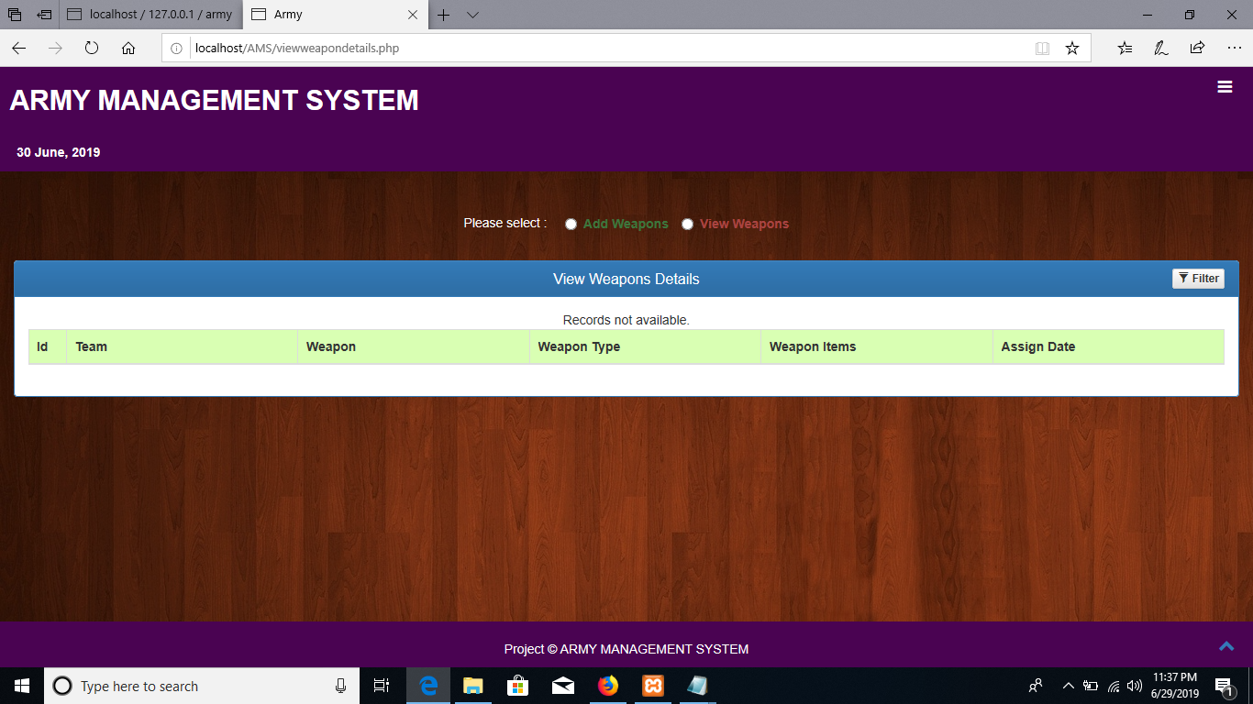

**Compose Mail & sent Mails & Inbox Mails:**

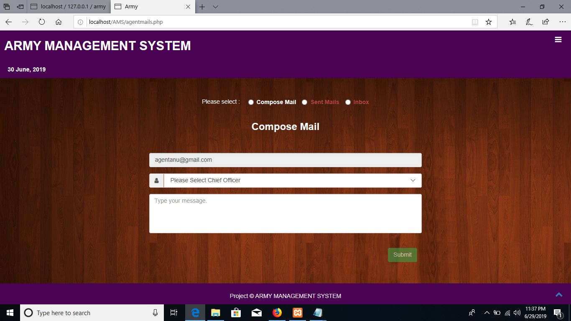

**View own weapons:**

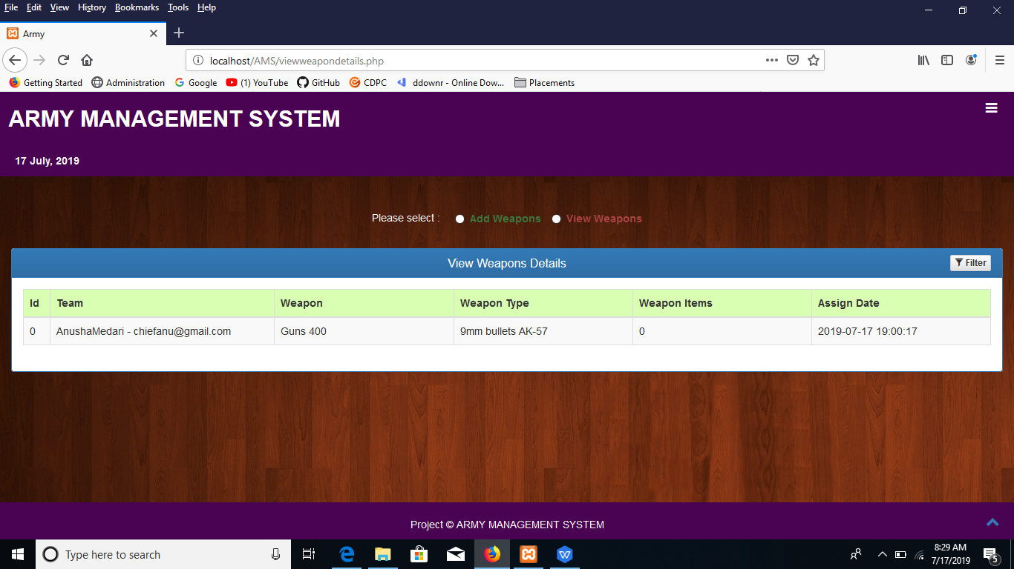

**Agent Profile:**

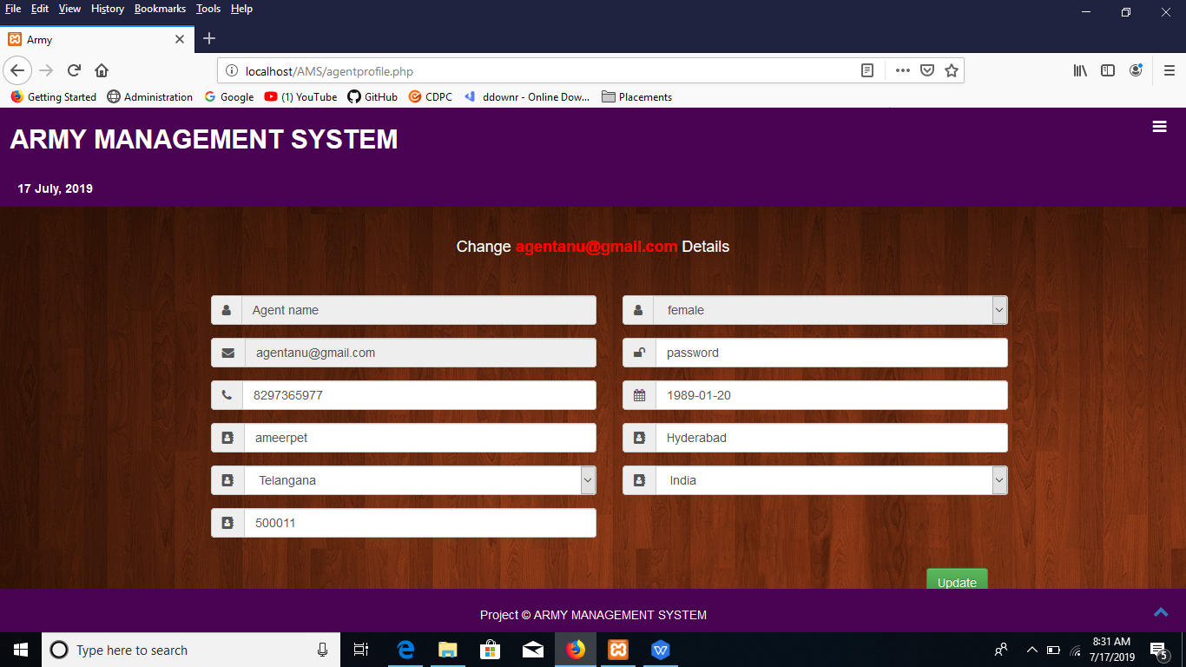

**Database:**

The underlying motivation of program testing is to affirm software quality with methods that can economically and effectively apply to both strategic to both large and small-scale systems.

**8.2. STRATEGIC APPROACH TO SOFTWARE TESTING**

**8.3. UNIT TESTING**

Unit testing focuses verification effort on the smallest unit of software design, the module. The unit testing we have is white box oriented and some modules the steps are conducted in parallel.

**1. WHITE BOX TESTING**

This type of testing ensures that

* All independent paths have been exercised at least once
* All logical decisions have been exercised on their true and false sides
* All loops are executed at their boundaries and within their operational bounds
* All internal data structures have been exercised to assure their validity.

To follow the concept of white box testing we have tested each form .we have created independently to verify that Data flow is correct, All conditions are exercised to check their validity, All loops are executed on their boundaries.

**2. CONDITIONAL TESTING**

In this part of the testing each of the conditions were tested to both true and false aspects. And all the resulting paths were tested. So that each path that may be generate on particular condition is traced to uncover any possible errors.

**3. DATA FLOW TESTING**

This type of testing selects the path of the program according to the location of definition and use of variables. This kind of testing was used only when some local variable were declared. The *definition-use chain* method was used in this type of testing. These were particularly useful in nested statements.

**4. LOOP TESTING**

In this type of testing all the loops are tested to all the limits possible. The following exercise was adopted for all loops:

All the loops were tested at their limits, just above them and just below them.

All the loops were skipped at least once.

For nested loops test the inner most loop first and then work outwards.

For concatenated loops the values of dependent loops were set with the help of connected loop.

Unstructured loops were resolved into nested loops or concatenated loops and tested as above.

Each unit has been separately tested by the development team itself and all the input have been validated.

**SYSTEM SECURITY**

9.1 INTRODUCTION

The protection of computer based resources that includes hardware, software, data, procedures and people against unauthorized use or natural

Disaster is known as System Security.

System Security can be divided into four related issues:

* Security
* Integrity
* Privacy
* Confidentiality

**SYSTEM SECURITY** refers to the technical innovations and procedures applied to the hardware and operation systems to protect against deliberate or accidental damage from a defined threat.

**DATA SECURITY** is the protection of data from loss, disclosure, modification and destruction.

**SYSTEM INTEGRITY** refers to the power functioning of hardware and programs, appropriate physical security and safety against external threats such as eavesdropping and wiretapping.

**PRIVACY** defines the rights of the user or organizations to determine what information they are willing to share with or accept from others and how the organization can be protected against unwelcome, unfair or excessive dissemination of information about it.

**CONFIDENTIALITY** is a special status given to sensitive information in a database to minimize the possible invasion of privacy. It is an attribute of information that characterizes its need for protection.

**9.3 SECURITY SOFTWARE**

System security refers to various validations on data in form of checks and controls to avoid the system from failing. It is always important to ensure that only valid data is entered and only valid operations are performed on the system. The system employees two types of checks and controls:

**CLIENT SIDE VALIDATION**

Various client side validations are used to ensure on the client side that only valid data is entered. Client side validation saves server time and load to handle invalid data. Some checks imposed are:

* VBScript in used to ensure those required fields are filled with suitable data only. Maximum lengths of the fields of the forms are appropriately defined.
* Forms cannot be submitted without filling up the mandatory data so that manual mistakes of submitting empty fields that are mandatory can be sorted out at the client side to save the server time and load.
* Tab-indexes are set according to the need and taking into account the ease of user while working with the system.

**SERVER SIDE VALIDATION**

Some checks cannot be applied at client side. Server side checks are necessary to save the system from failing and intimating the user that some invalid operation has been performed or the performed operation is restricted. Some of the server side checks imposed is:

* Server side constraint has been imposed to check for the validity of primary key and foreign key. A primary key value cannot be duplicated. Any attempt to duplicate the primary value results into a message intimating the user about those values through the forms using foreign key can be updated only of the existing foreign key values.
* User is intimating through appropriate messages about the successful operations or exceptions occurring at server side.
* Various Access Control Mechanisms have been built so that one user may not agitate upon another. Access permissions to various types of users are controlled according to the organizational structure. Only permitted users can log on to the system and can have access according to their category. User- name, passwords and permissions are controlled o the server side.
* Using server side validation, constraints on several restricted operations are imposed.

**CONCLUSION**

The Indian Military framework preceding the Turkish intrusion which considered the episodes of Mahabharata as the goals of war, neglected to satisfy that standard. Inspite of having established deals with commonwealth of their predecessors, they never considered the proposals made in progress. No outward change in the military system, weapons, association and so forth, had occurred in the Indian armed force from the times of the Guptas, we anyway locate a vast scale association of the military framework. He shaped the focal armed force which comprised of the elephantry, cavalry and infantry.

**REFERENCES:**

* PHP5 and MySQL by W Jason Gilmore (Apress)
* PHP Web Development by Allan Kent and David Powers (Apress)
* Professional PHP4 by Christopher Scollo
* PHP 5 Unleashed by John M. Coggeshall
* Advanced PHP Programming by George Schlossnagle
* Programming PHP by Kevin Tatroe
* Zend PHP Certification Study Guide by Zend Technologies

**FOR MySQL**

MySQL (2nd Edition) (Developer's Library) by Paul Dubois

* Php and MySql---Larry Ullman

**FOR JavaScript**

http://www.w3schools.com/

http://www.zend.com/php/beginners/

<http://www.devshed.com/c/b/PHP/>

http://www.phpfreaks.com/